Small Angle X-ray Scattering (SAXS) User Manual

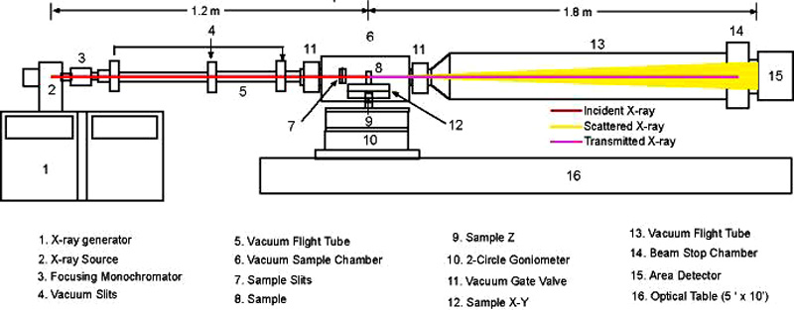
Before you run:
- You must be trained in X-ray and lab safety. Contact Youli or Mario on how to do this.
- Go to the X-ray lab (Room 1012) and look at the setup to see if the spectrometer can accomidate your samples. Also check the specifications to make sure the range of the spectrometer is what you are interested in.
- Schedule a time to be trained on the SAXS by contacing Youli or Mario.
- Have your samples prepared and ready to mount in order to maximize your time collecting data.
Aligning Samples:
- Make sure the shutter is closed! (shutter light on x-ray machine and light post should be off)
- Mount sample on the xyz (x is horizontal, z is vertical, and y is parallel to the beam) stage.
- Use Spec on the computer inside of the hutch to align the sample on the beam spot that is marked on the monitor.
- To change the x position type “wm x”, for “where motor x”, to find the current x position of the sample.
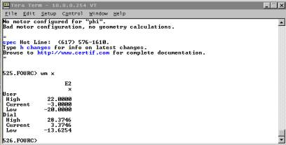
Here the current x-position is –3. The bottom “Dial” values are offsets that spec stores from the original settings.
- To change the position of the sample 7mm in the positive direction type
“umv x 4”, which will move x to x=4 (mm), updating positions while moving.
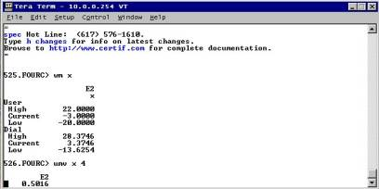
Here x is moved 7 mm in the positive direction from –3 to 4.
- Do this with x and z until the sample is in the beam spot.
- Quit Spec by typing “quit” and leave the hutch making sure to close the door all the way.
- Your sample is now in the beam and you are ready to collect data.
Collecting data:
- On the computer outside of the hutch start the Bruker data collection software by going to START->PROGRAMS->BRUKER SAXS->SAXS NODIF
- Turn on the X-ray beam by openning the shutter from shutter control box next to the computer.
- Start an acquisition in the Bruker software by going to COLLECT->DETECTOR->ADD
- Type in the desired time (in seconds) you would like to run your sample then press return to start the collection.
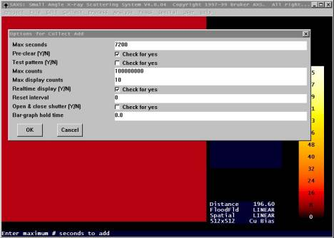
Example of a 2 hour acquisition ready to go.
- After the collection has completed save the image in your directory and the export it for analysis.
Exporting data:
- The image needs to be converted to a tiff so that FIT2D can read it.
- This can be done by going to START->PROGRAMS->BRUKER SAXS->frm2frm
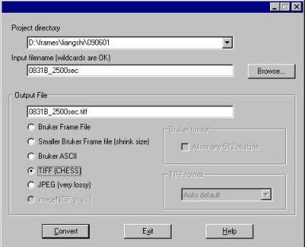
frm2frm converts Bruker format to 16-bit tiff.

- Now that you have a tiff you can use FIT2D to process your data.
Basic data processing:
- Open FIT2D by double clicking the shortcut on the desktop. Accept the terms and then the dimension screen say “OK”.
- On the scientific interfaces screen select “SAXS/GISAXS”->"INPUT” and select the file you just converted and select “OK”.
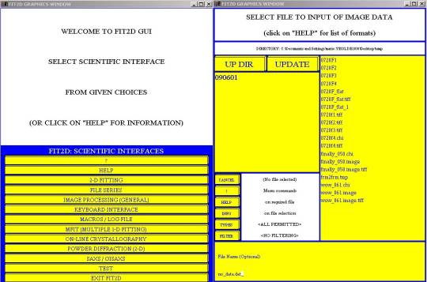
Scientific interface screen and the screen after INPUT is selected. Just click the files once.
- After your file is selected you should see your 2D image. To find the peak positions hit “CAKE” find the beam center, if there is no change just select “NO CHANGE”.
- To start the integration at 0, 0 click the large yellow region on the bottom center, click it again to go 360 degrees, click it again to start the inner radius at the beam center, then click a point on the image to set the outer radius.
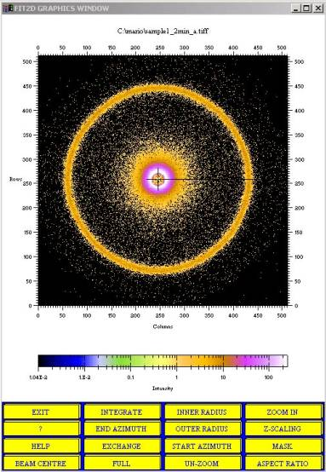
Image ready to integrate.
- Now click “INTEGRATE” to start the integration.
- Click “OK” for the experimental geometry page.
- On the next screen change the Number of Azimuthal Bins to 1. This has to be done each time an integration is performed. Select “OK” to generate a plot of intensity versus q.
- To output a two column ascii file select “EXIT” and then select “OUTPUT” to output the file to your directory.
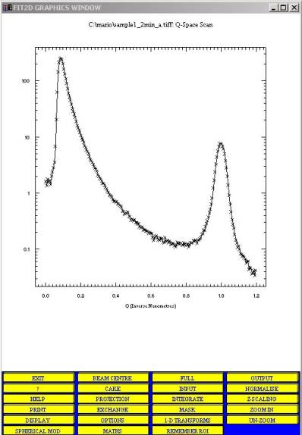
Plot that is ready to output an ascii file that can be read by any plotting program.
- In the Output screen select “CHIPLOT” then select “FILENAME” and choose the correct directory to place the file and press return and then select “OK”. This will put the file in the directory you selected and by default names the file the same as the input file but with a *.chi extension.
- To repeat the process select “EXCHANGE” and then “INPUT” and do everything as before.

